**Vaultionizer** - ***Security without exception***

|  |  |  |  |
| --- | --- | --- | --- |
| **Members** | **Contact** | **Time Spent** | **RUP Roles** |
| Julien Meier | meier.julien2000@gmail.com | 172 h | 1. Test Manager 2. Test Analyst 3. Graphic Artist |
| Johannes Quast | johannesquast@outlook.de | 176 h | 1. Test Manager 2. Deployment Manager 3. Project Manager |
| Yannic Hemmer | ya.hemmer@gmail.com | 120 h | 1. Requirements Specifier 2. Test Analyst 3. Graphic Artist |
| All | contact@vaultionizer.com | 469 h | 1. System Analyst 2. Software Architect 3. Integrator 4. Implementer 5. Test Designer |

Members, E-Mail, Time Spent (14 June), Roles

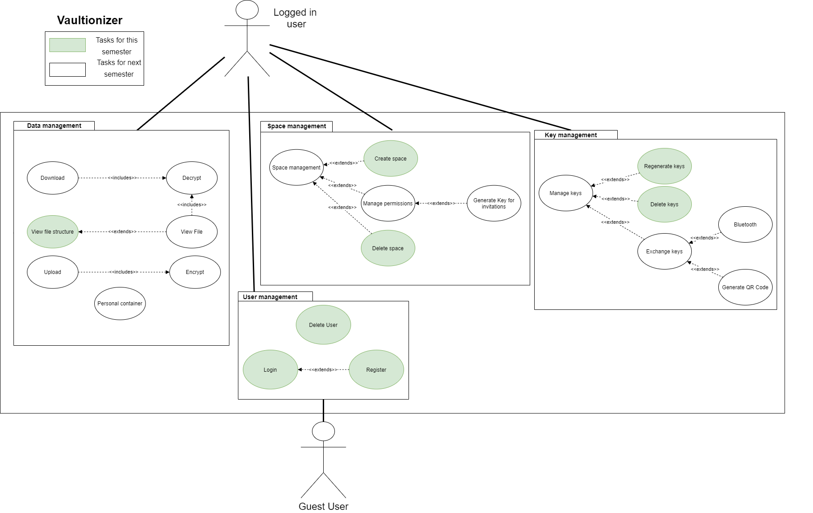

Overall UC-Diagram (Green is Midterm, Everything else is Final)